Error Analysis Note
On 1,500 clean test images the augmented model produces 75 false positives (9.8% of real images) and 33 false negatives (4.5% of AI images) at a 0.5 threshold. We are 2.3× more likely to wrongly flag a real photograph than to miss an AI one — the wrong direction for a platform, where falsely accusing a photographer is the costlier error.
False positives. 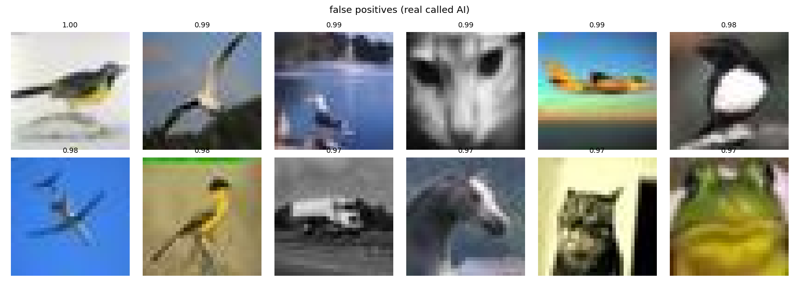
The twelve most confident false positives.
Real photographs scored 0.97 to 1.00 and they share a visual signature: a singular centred object on a smooth background. Four birds and two aircraft against open sky, a horse against pale cloud, a cat against a blank wall. This is the compositional signature of a generated image, and the classifier applies it to real photographs that happen to share it. The deployment risk is therefore specific rather than random: portraits, product shots and wildlife photography are systematically over-flagged.
False negatives.
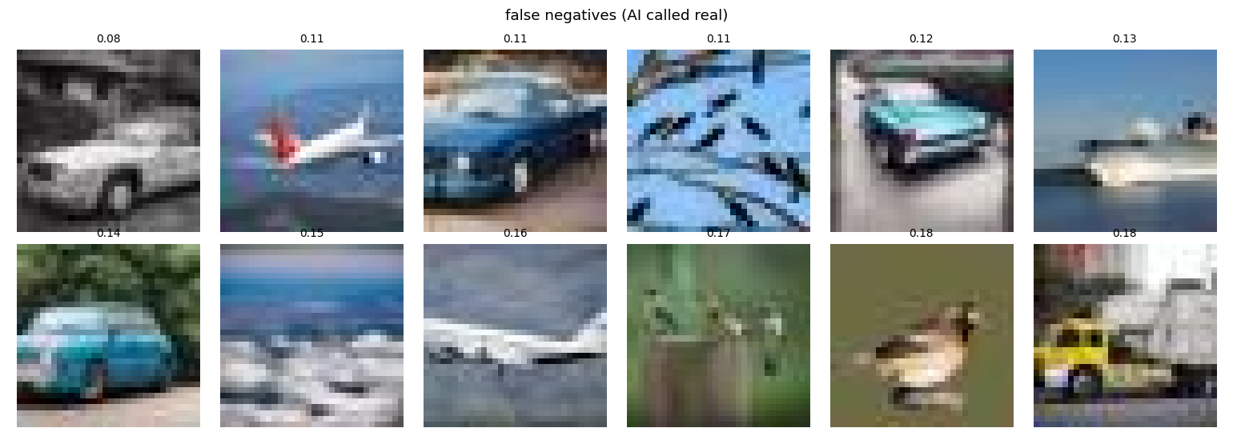
Cause. CIFAKE images are 32×32, upsampled 7× to reach the backbone's 224×224 input, so no generator-level frequency artifact survives. A linear probe on DINOv2 features can only key on semantics and composition, which is exactly what the false positives show. We expect this failure mode to diminish at native resolution, where low-level fingerprints remain intact.
Trade-offs.
- Robustness vs. clean accuracy: largely dissolved here: chained augmentation cost 0.002 clean AUC and bought 0.024 robust AUC.
- Generalisation: CIFAKE contains one generator family, so no cross-generator claim is possible.
- Calibration vs. discrimination: under 0.25× resize the baseline held AUC 0.798 while accuracy fell to 0.548. The ranking survived degradation; the threshold did not. This is why we report both metrics.
- Where the passport helps: 94% of errors fall in the least-stable half of predictions, leaving an auto-actionable half at 99.2% accuracy.

